What have you done so far? (Group)

Podcast Questions, logo/mascot for the podcast as well as a name for it. Also, we found a room where we can film the podcast as well as a time slot in which it is free.

What needs to be completed next? (Group)

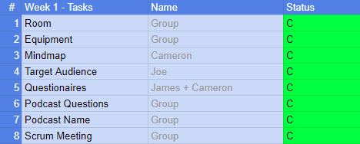

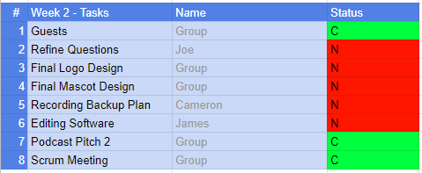

What is your job after this meeting? (Individual)

Joseph -

Discuss the questions the other members of the group have thought of and elaborate on them so they will fit into the podcast.

Cameron -

In case the recording room is unusable I will create a backup plan on how to make the podcast without a room.

James -

Finish off the final design for the logo/ mascot for the podcast and then find a suitable editing software for editing the podcast.

What have you completed at the end of today’s session? What do you need to complete before the next meeting? (Individual and group)

Cameron should have a backup plan in case the recording room isn't useable to record the podcast.

James should have found a suitable editing software and finished the final design of the mascot for our podcast.

Joseph should have a set of questions for each member which have been elaborated on so that they provide a good conversation for the podcast.